**IOT BASED ATTENDANCE MANAGEMENT SYSTEM**

**BY**

**ADEGBEYENI TEMITOPE OLUWASEUN**

**160408506**

**SUBMITTED TO**

**THE DEPARTMENT OF ELECTRICAL AND ELECTRONICS ENGINEERING**

**FACULTY OF ENGINEERING**

**UNIVERSITY OF LAGOS**



**IN PARTIAL FULFILMENT OF THE REQUIREMENTS FOR THE AWARD OF THE DEGREE OF BACHELOR OF SCIENCE**

**(B.SC. BACHELOR OF SCIENCE IN COMPUTER ENGINEERING)**

**SUPERVISED BY:**

**DR. A.O. GBENGA-ILORI**

**OCTOBER, 2021.**

# CERTIFICATION

This is to certify that this project “IOT based attendance management system” was carried out by ADEGBEYENI TEMITOPE OLUWASEUN and submitted in partial fulfillment of the requirements for the award of a B.Sc. (Hons) Degree in the computer engineering department of the University of Lagos, Lagos, Nigeria.

…………………………………… ……………………………………

Author Supervisor

Mr Adegbeyeni Temitope Dr. A.O Gbenga Ilori

………………………………… ………………………………………

Dr. A.O Gbenga Ilori Dr. S Adetona

Project Coordinator Head of Department

# ACKNOWLEDGEMENT

I appreciate God for seeing me through my program at the University of Lagos.

I acknowledge the efforts of my project Supervisor, Dr A.O. Gbenga Ilori, who gave me all the ingredients that I needed for this project. I thank her for being patient with me since the start of the project. I appreciate her words of encouragement, feedback and constructive criticism. I would also appreciate all my lecturers for the knowledge they have impacted on me since my first day on campus.

I appreciate my loving parents, Mr. & Mrs Adegbeyeni, for their time, resources, prayers, funds and moral support.

Special recognition goes to my uncle and his wife, Mr. & Mrs Akingbondere for their support, love and prayers during my entire stay at the University of Lagos.

I would also like to thank my cousins, Akingbondere Oluwanifemi, Akingbondere Deborah, Akingbondere Daniel for their support, understanding and patience.

To my sister, Miss Adegbeyeni Ifedayo, I say a big thank you for your support, advice and honest feedback since the beginning of this project.

I also acknowledge the efforts of my friends and colleagues, Oyedele Demilade, Dooshima Anger, Tomiwa Adekalu, Sola Fadare, Fagboyo Ayomide for their support, assistance, ideas, guidance and mentorship.

God bless you all.

# ABSTRACT

Most institutions still use the paper system to maintain students’ attendance. This method has proven to be inefficient and time-consuming. An efficient management system needs to replace the old paper system. This work is aimed at the development of a fingerprint-based attendance management system. This system makes attendance monitoring faster, easier, and more secure than the paper system. The proposed system uses a fingerprint module to scan students’ fingerprints to take their attendance. This system solves the problem of proxy attendance and other cons of the paper system. The device was developed with the use of an Atmega328p microcontroller, a wifi module for sending data to the internet. The attendance is taken course by course, and it is saved in the cloud database as soon as it is taken. A web application was developed for easy and convenient management of the attendance system. Both Students and Lecturers can access the web platform and the students can view their attendance reports. This study contains a detailed analysis of software and hardware interface architectures.

**TABLE OF CONTENTS**

CERTIFICATION ii

ACKNOWLEDGEMENT iii

ABSTRACT iv

LIST OF ABBREVIATIONS ix

INTRODUCTION 1

1.1 OVERVIEW 1

1.2 PROBLEM STATEMENT 2

1.3 AIMS OF PROJECT 2

1.4 OBJECTIVES OF THE PROJECT 3

1.5 SCOPE OF REPORT 3

LITERATURE REVIEW 5

2.1 ATTENDANCE MANAGEMENT SYSTEM 5

2.2 RELATED WORKS 5

2.3 BIOMETRIC TECHNOLOGY 7

2.3.1 FINGER VEIN 7

2.3.2 HAND GEOMETRY RECOGNITION 8

2.3.3 FINGERPRINT SYSTEM 8

2.3.4 OCULAR-BASED IDENTIFICATION SYSTEMS 9

STATEMENT OF PROBLEM AND DESIGN SPECIFICATIONS 11

3.1 PROBLEM STATEMENT 11

3.2 DESIGN SPECIFICATION 11

3.2.1 HARDWARE SPECIFICATIONS 11

3.2.1.1 FINGERPRINT SENSOR (R305) 13

3.2.1.2 NODEMCU: 14

3.2.1.3 LCD SCREEN 15

3.2.1.4 RTC MODULE 16

3.2.1.5 ATMEGA328P MICROCONTROLLER 17

3.2.2 SOFTWARE SPECIFICATIONS 20

3.2.2.1 ARDUINO INTEGRATED DEVELOPMENT ENVIRONMENT 20

3.2.2.2 MICROSOFT SQL SERVER 20

3.3 WORKFLOW OF THE SYSTEM 24

3.4 MODE OF OPERATION: 25

DESIGN ANALYSIS 26

4.1 INTRODUCTION 26

4.2 FLOWCHART OF PROJECT EXECUTION 26

4.3 PROGRAMMING THE MICROCONTROLLER: 27

4.4 BUILDING THE DEVICE 28

4.4.1 DEVICE INSTRUCTIONS: 31

4.4.2 ALGORITHM FOR ENROLLING NEW STUDENTS: 32

4.4.3 ALGORITHM FOR TAKING ATTENDANCE: 32

4.5 DEVELOPING THE WEB PLATFORM 33

4.6 LIMITATIONS TO THE DEVICE 37

CONCLUSION 38

5.1 SUGGESTION FOR FUTURE WORKS 38

REFERENCES 39

**Table of Figures**

Figure 2. 1: Finger vein technology being applied. 7

Figure 2. 2: Hand Geometry 8

Figure 2. 3: Fingerprint scanner in action. 9

Figure 2. 4: Retina scanner 10

Figure 3. 1: Block Diagram of the system 12

Figure 3. 2: Flowchart of project execution. 13

Figure 3. 3: R305 Fingerprint module 14

Figure 3. 4: NodeMCU board 15

Figure 3. 5: LCD Screen 16

Figure 3.6: RTC DS3231 Module 17

Figure 3.7: Pin out Diagram of the ATmega328p Microcontroller 18

Figure 3. 8: Circuit Diagram 19

Figure 3. 9: A snippet of an Arduino code 20

Figure 3. 10: Workflow of the proposed system24

Figure 4. 1: Flowchart of project execution 26

Figure 4. 2: A C-Programming language function for enrolling students’ fingerprints. 28

Figure 4. 3: The PCB layout of the project 29

Figure 4. 4: The complete project 30

Figure 4. 5: Workflow of the attendance procedure 31

Figure 4.6: The Login page 33

Figure 4.7: Flow chart of the Login page 34

Figure 4. 8: The Admin Home page. 35

Figure 4. 9: Admin creating new lecturer account 35

Figure 4. 10: The Attendance record. 36

Figure 4. 11: Use case diagram of the attendance management system 37

# 

# LIST OF ABBREVIATIONS

1. IoT – Internet of Things
2. RFID – Radio Frequency Identification
3. LCD – Liquid Crystal Display.
4. SQL – Structured Query Language
5. SAMS - Smart Attendance Management System
6. NodeMCU – Node Micro-controller Unit.

CHAPTER 1

# INTRODUCTION

## 1.1 OVERVIEW

In the 21st century, technology is becoming an integral part of every modern-day classroom. As a lecturer, you must recognize and make use of the different technologies in the classroom. The lecturers shouldn’t stress themselves by using the old paper method system for taking attendance. There are some tech-inspired methods of managing attendance that has proven to be efficient, reliable and less time-consuming.

* The barcode system where each student has their barcode ID
* The magnetic card attendance system where students are given a card as a form of identity, but this system is flawed when students tend to forget or lose their card.
* The fingerprint attendance system where students use their fingerprints as signatures.

The fingerprint attendance system has been gaining popularity due to the unique nature of fingerprints. Fingerprints are also considered the most reliable type of biometric system [1].

This project uses a fingerprint module to scan students’ fingerprints. Initially, students are to register their fingerprints on the database. Once the students enter the class, the biometrics of their fingerprints will be scanned and sent to the database. The student will be marked present only if their fingerprints match with what is in the database. This system is highly secured, reliable and time saving than the manual system.

## 1.2 PROBLEM STATEMENT

In our institutions, managing attendance has proven to be a difficult task; the traditional method of using paper is time-consuming and inefficient. This method is a waste of students’ lecture time, energy and also a big distraction to students. Traditional methods of monitoring students’ attendance can be used in a variety of ways, including:

* Requesting all students to write their names and signatures on a sheet of paper.
* By calling out the names of students.
* By conducting a mini test during the lecture.

These methods have their drawbacks; calling out student names takes a long time out of the lecture period. A class that uses the old paper or attendance sheet system requires the students to pass the sheet to one another to mark attendance [2]. This method will take time before it goes round the class. Besides that, students can be distracted from the main lecture and there is a possibility that some students might miss their turn or sign in for their friends. Hence, the aim of taking attendance has been defeated. There is a need to replace the old paper system with a more secured and advanced system.

## 1.3 AIMS OF PROJECT

This project is aimed at designing and developing an IoT based attendance management system. A microcontroller-based circuit and a fingerprint sensor are used to implement the circuit. This project is aimed at providing schools with a better, automated, functional and affordable attendance management system than the old paper system.

## 1.4 OBJECTIVES OF THE PROJECT

The objectives of this project are:

* To build an IoT based attendance management system that works with an Arduino microcontroller.
* To enable the attendance system to be managed remotely.
* For this project, students’ fingerprints will be enrolled and saved on the database.
* To develop a web-based application for managing the attendance records.
* To provide a periodic report of the attendance sheet to the lecturer.

## 1.5 SCOPE OF REPORT

The interfaces between the fingerprint modules and the Arduino microcontroller are the subject of this project. The coding of the microcontroller to perform the main task of managing students’ attendance and also the design of a database to keep the records of both students and lecturers.

The design analyses of the device, the various parts and their specifications are explained in this report.

A program was developed using the Arduino C programming language to provide a fully functional automated attendance management system with features such as:

* Registering students’ fingerprints
* Editing or removal of students’ records

The database receives the fingerprint ID of the students through the nodeMCU, and all daily records are stored on the database.

A web-based application is to be built to provide easy accessibility to the records in the database. Lecturers will be able to view and download the attendance sheet, as well as grade students on their attendance at lectures.

CHAPTER 2

# LITERATURE REVIEW

## 2.1 ATTENDANCE MANAGEMENT SYSTEM

The traditional means of taking attendance involves passing the attendance sheet from teacher to students and the teacher piling up the attendance sheets till the end of the academic session. This method is time-consuming, non-efficient and there can be a loss or damage to the attendance records.

The Internet of Things (IoT) has given us advanced methods of taking attendance. These methods solve the limitations and cons of the traditional method. In this project, I will be discussing how to manage the school attendance system with the aid of fingerprint technology.

## 2.2 RELATED WORKS

Talaiya et.al [3] worked on an attendance management system using fingerprint sensors. A fingerprint enrollment is first carried out where the students register their fingerprint and identification code on the database. Students’ fingerprints will then be compared to the database records to mark the attendance.

Mahinderjit [4] used RFID technology to implement an attendance management system. In their SAMS, students are to have a unique RFID tag that has their ID number on it. Students must scan the RFID tags every time they enter the class. The RFID receiver will read the identification code on the tag and send it to the database.

A. Kassem et.al [5] also used the RFID method. They proposed a system that boasts higher reliability, time-saving and ease of control than the manual system.

Kadry and Smaili [6] used Iris recognition to identify and verify the students. They also used wireless transmission to solve the problem of connectivity and poor transmission system between the workstation and database.

Sittampalam and Ratnarajah [7] used fingerprint sensors and cloud computing to develop an IoT solution for a SAMS. Their system was able to collect students’ attendance with the aid of the fingerprint sensor and they implemented web services for automatic management of data.

Kamelia et.al[8] developed a SAMS using fingerprint sensors and GPS in smart phones. The GPS is to access users’ current location. They also developed an android application for monitoring the attendance system.

Swamendu Ghosh et.al [9] developed a SAMS using a fingerprint sensor, Bluetooth sensor and an Arduino. They also developed a mobile application for managing the SAMS. Their SAMS is made active only by an authorized fingerprint user who can be the lecturer. The purpose of this authorized fingerprint is to help avoid misuse of the device.

Dr Sanjay et.al [10] developed a manifold attendance system. A case whereby the image of a group of people are captured and sent to the database for verification. This method divides the students into smaller groups and student attendance is taken in groups. One of their project's goals is to shorten the queue or time spent taking attendance.

Shubhobrata et al [10] developed a SAMS that uses face recognition. They also implemented the techniques of deep learning to train the images of the students and to achieve high success in recognizing students’ faces.

## 2.3 BIOMETRIC TECHNOLOGY

The term “biometric” comes from two Greek words: “bio”, which means “life”, and “metric”, which means “measurement” [11]. The measurement and study of humans' distinctive behavioral and physical features are known as biometrics [12].

Biometric technology is a means of identifying individuals using their unique features or characteristics. Examples of biometric technologies include facial recognition, finger-vein technology, voice recognition, fingerprints, etc.

### 2.3.1 FINGER VEIN

Finger vein technology is a technique that recognizes an individual based on images of his finger vein patterns. During authentication, a person’s vascular pattern is captured and compared to previously obtained data.

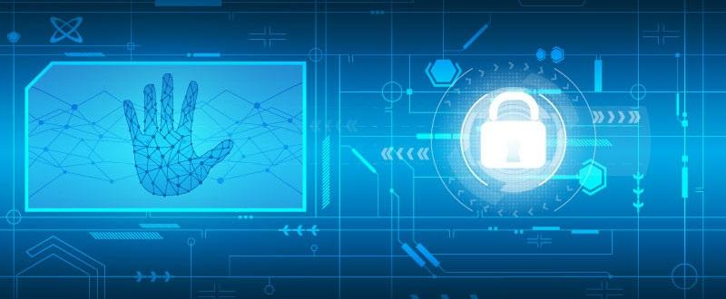

Figure 2. 1: Finger vein technology being applied.

Source: Adapted from [13].

### 2.3.2 HAND GEOMETRY RECOGNITION

Hand Geometry is considered the oldest type of biometric technique [14]. During authentication, it uses the physical dimensions of the human hand.

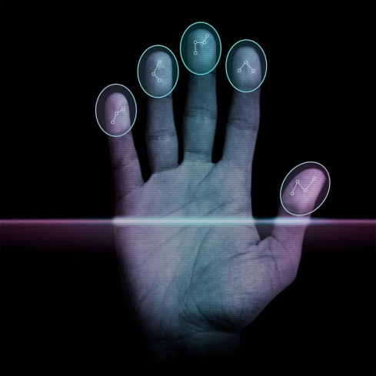

Figure 2. 2: Hand Geometry

Source: Adapted from [15]

### 2.3.3 FINGERPRINT SYSTEM

This is the most common type of biometric technology. A user’s fingerprint is scanned and the image of the finger is analyzed and sent to a database. The fingerprint image is then compared with a previously registered fingerprint for authentication.

Advantages of Fingerprint system

* Improved Security
* Higher accuracy
* Faster access
* Greater convenience
* Increased affordability

Cons of Fingerprint system

* False readings when fingers are wet or dirty.
* Biometrics can be costly to implement.

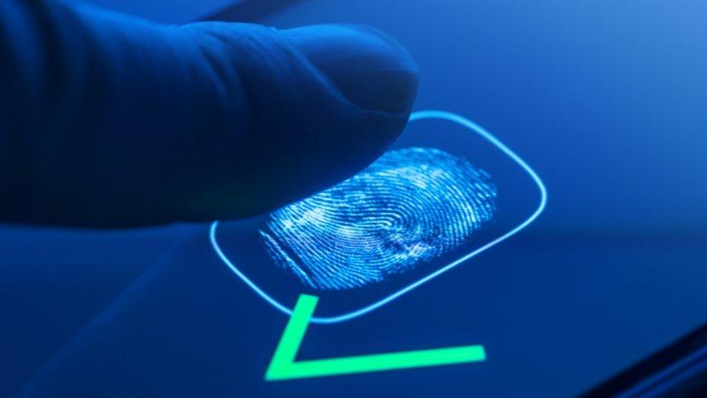

Figure 2. 3: Fingerprint scanner in action.

Source: Adapted from [16]

### 2.3.4 OCULAR-BASED IDENTIFICATION SYSTEMS

Ocular based identification relies on unique eye characteristics to identify an individual. Ocular based technologies include:

Iris Recognition

Retina Scanning

Iris Recognition is an important type of biometric technique. It uses the iris pattern on the pupil to recognize individuals.

In retina scanning, the patterns of blood vessels on the eyeball are captured and analyzed. Every eyeball has its unique pattern of blood vessels which makes retina recognition highly unique.

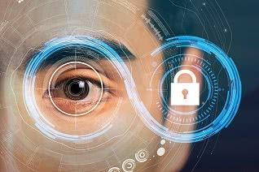

Figure 2. 4: Retina scanner

Source: adapted from [17]

Other notable biometric systems include the face, voice recognition, facial thermogram, ear shape, signature etc.

CHAPTER 3

# STATEMENT OF PROBLEM AND DESIGN SPECIFICATIONS

## 3.1 PROBLEM STATEMENT

Taking the attendance of every student within the lecturers’ allocated period is time consuming, especially when the class is large. They lose up to 45 minutes of the total allocated hours, which is approximately two hours per session. There is a need to replace this method with a time-saving and effective system.

## 3.2 DESIGN SPECIFICATION

The design methodology for this project is grouped into two:

1. Hardware Specifications
2. Software Specifications.

### 3.2.1 HARDWARE SPECIFICATIONS

The requirements for this project include:

* 16x2 LCD Screen
* Fingerprint Module
* WIFI ESP8266 Module (Node MCU)
* 5v, 700mA Power Supply
* Keypad
* Buzzer
* DS3231 RTC Module
* Connecting wires

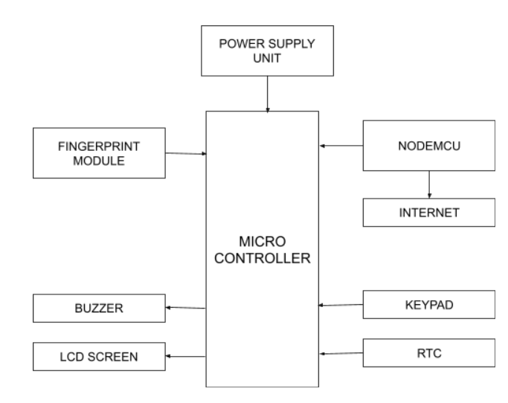

Figure 3. 1: The Block diagram of the system

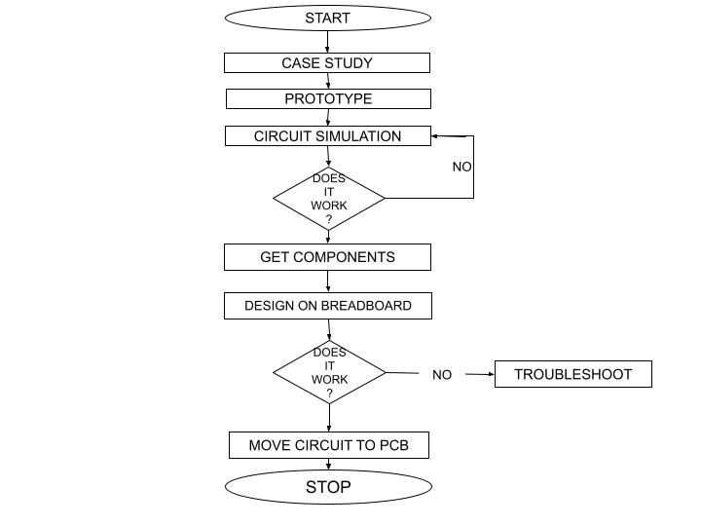

Figure 3. 2: Flowchart of project execution.

#### 

#### 3.2.1.1 FINGERPRINT SENSOR (R305)

Over the years, the fingerprint system has gained more popularity than any other type of biometric technique. It can be implemented in smart phones, AT Machines, door security systems and other microcontroller-based devices. The first step in fingerprint processing is fingerprint enrollment, while the next step is fingerprint matching.

In Fingerprint enrollment, a user enters his/her finger twice, the system reads the two entries of the finger images, after processing it, it will build a model of the finger and also store the model [18].

The user enters their finger via the fingerprint module, and the machine generates a template of the image and compares it to the templates in the fingerprint database until it finds a match [18].

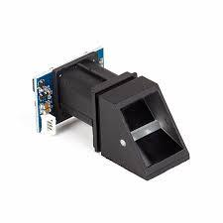

Figure 3. 3: R305 Fingerprint module

Source: adapted from [19].

|  |  |
| --- | --- |
| Name | Description |
| GND | It is connected to the ground signal. |
| TX | Data output. TTL logical level |
| RX | Data input. TTL logical level |
| VCC | +5 VDC |

Table 3.1: Serial Communication of R305 Fingerprint module

#### 3.2.1.2 NODEMCU:

NodeMCU is a Lua-based open-source firmware and development board for IoT applications. It's powered by an Espressif ESP8266 WiFi module [20]. Its microprocessor runs at a clock frequency of 80MHz to 160MHz. For data storage, the NodeMCU has 128kb RAM and 4MB Flash memory [20]. It is powered through the VIN pin or with a micro USB connector. It supports SPI, I2C, and UART interfaces.

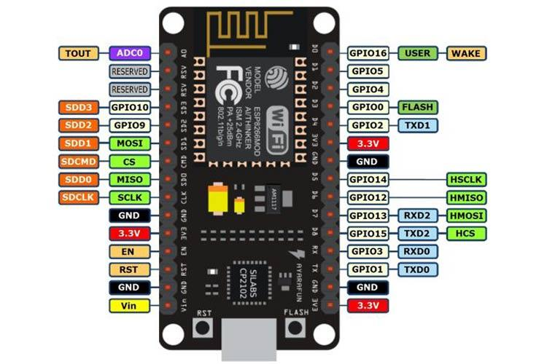

Figure 3. 4: NodeMCU board

Source: adapted from [20]

#### 3.2.1.3 LCD SCREEN

LCD (Liquid Crystal Display) is a type of flat panel display that operates primarily with liquid crystals. LEDs are widely used in cell phones, televisions, computer monitors, and instrument panels, and they have a wide range of applications for consumers and enterprises.

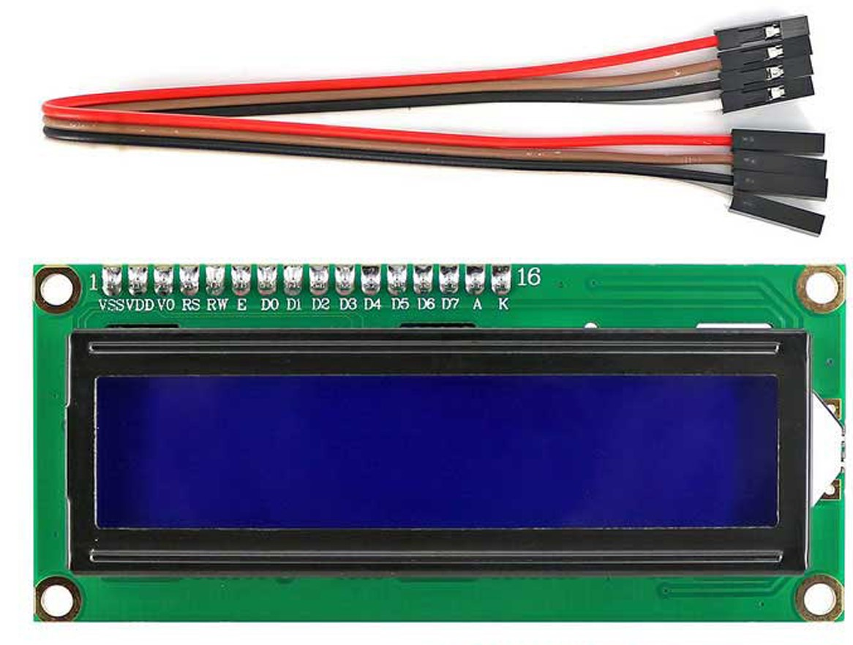Figure 3. 5: LCD screen

Source: adapted from [21]

#### 

#### 3.2.1.4 RTC MODULE

RTC (Real Time Clock) module is a computer clock built to keep track of time. It records time in seconds, minutes, hours, days, months and even years. The RTC Module consumes low power and improves frequency stability.

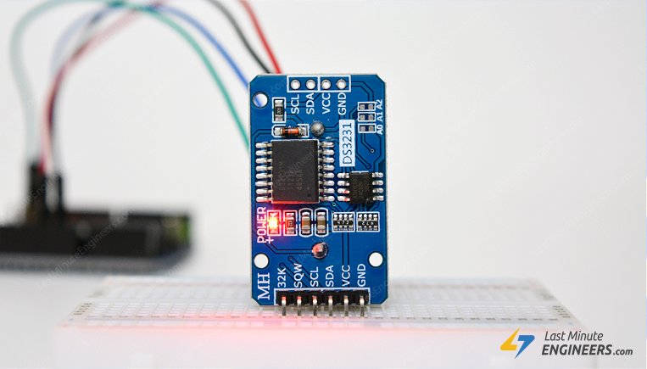

Figure 3.6: RTC DS3231 Module

Source: adapted from [23]

#### 3.2.1.5 ATMEGA328P MICROCONTROLLER

The ATmega328p is a high performance, low power 8-bit microcontroller that can execute 131 complex commands in a single clock cycle. This is possible due to its sophisticated RISC architecture. It is typically seen in some Arduino boards like Arduino Uno, Arduino Fio. It uses 32kb for RAM, 2kb as ROM, 23 general-purpose I/O lines. The ATmega328p IC has internal protections and diverse programming approaches which assist engineers in prioritizing this microcontroller for various purposes.

Features of the ATmega328P microcontroller

1. It has 28 pin outs.
2. It has an 8-bit AVR Central Processing Unit.
3. It operates between +1.8volts to +5volts.
4. It has 23 programmable inputs and outputs pin outs.
5. It boasts of an 8MHz inner oscillator.

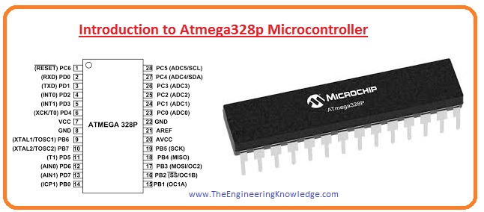

Figure 3.7: Pin out Diagram of the ATmega328p Microcontroller

Source: adapted from [24]

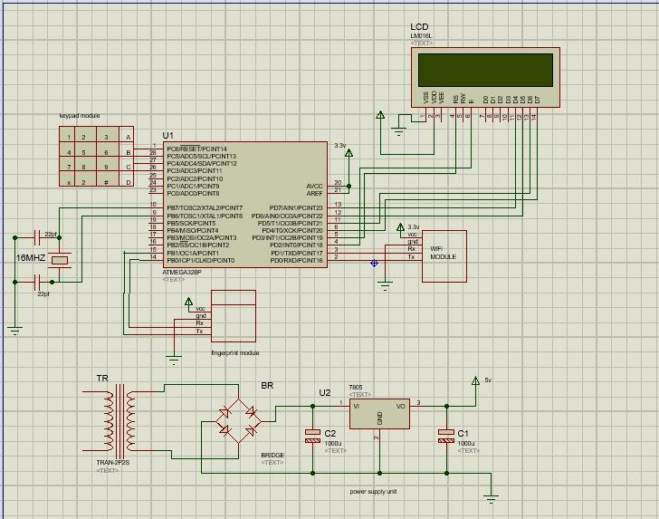

Figure 3. 8: Circuit Diagram of the system.

### 3.2.2 SOFTWARE SPECIFICATIONS

#### 3.2.2.1 ARDUINO INTEGRATED DEVELOPMENT ENVIRONMENT

The official program introduced by Arduino.cc is the Arduino. It's primarily used for writing, compiling, and uploading code to the Arduino device. It is easy to use, install and program.

Arduino IDE supports both C and C++ languages. It is available on operating systems like Windows, MAC, and Linux [22]. A Program or code written on the IDE is called a “sketch”.

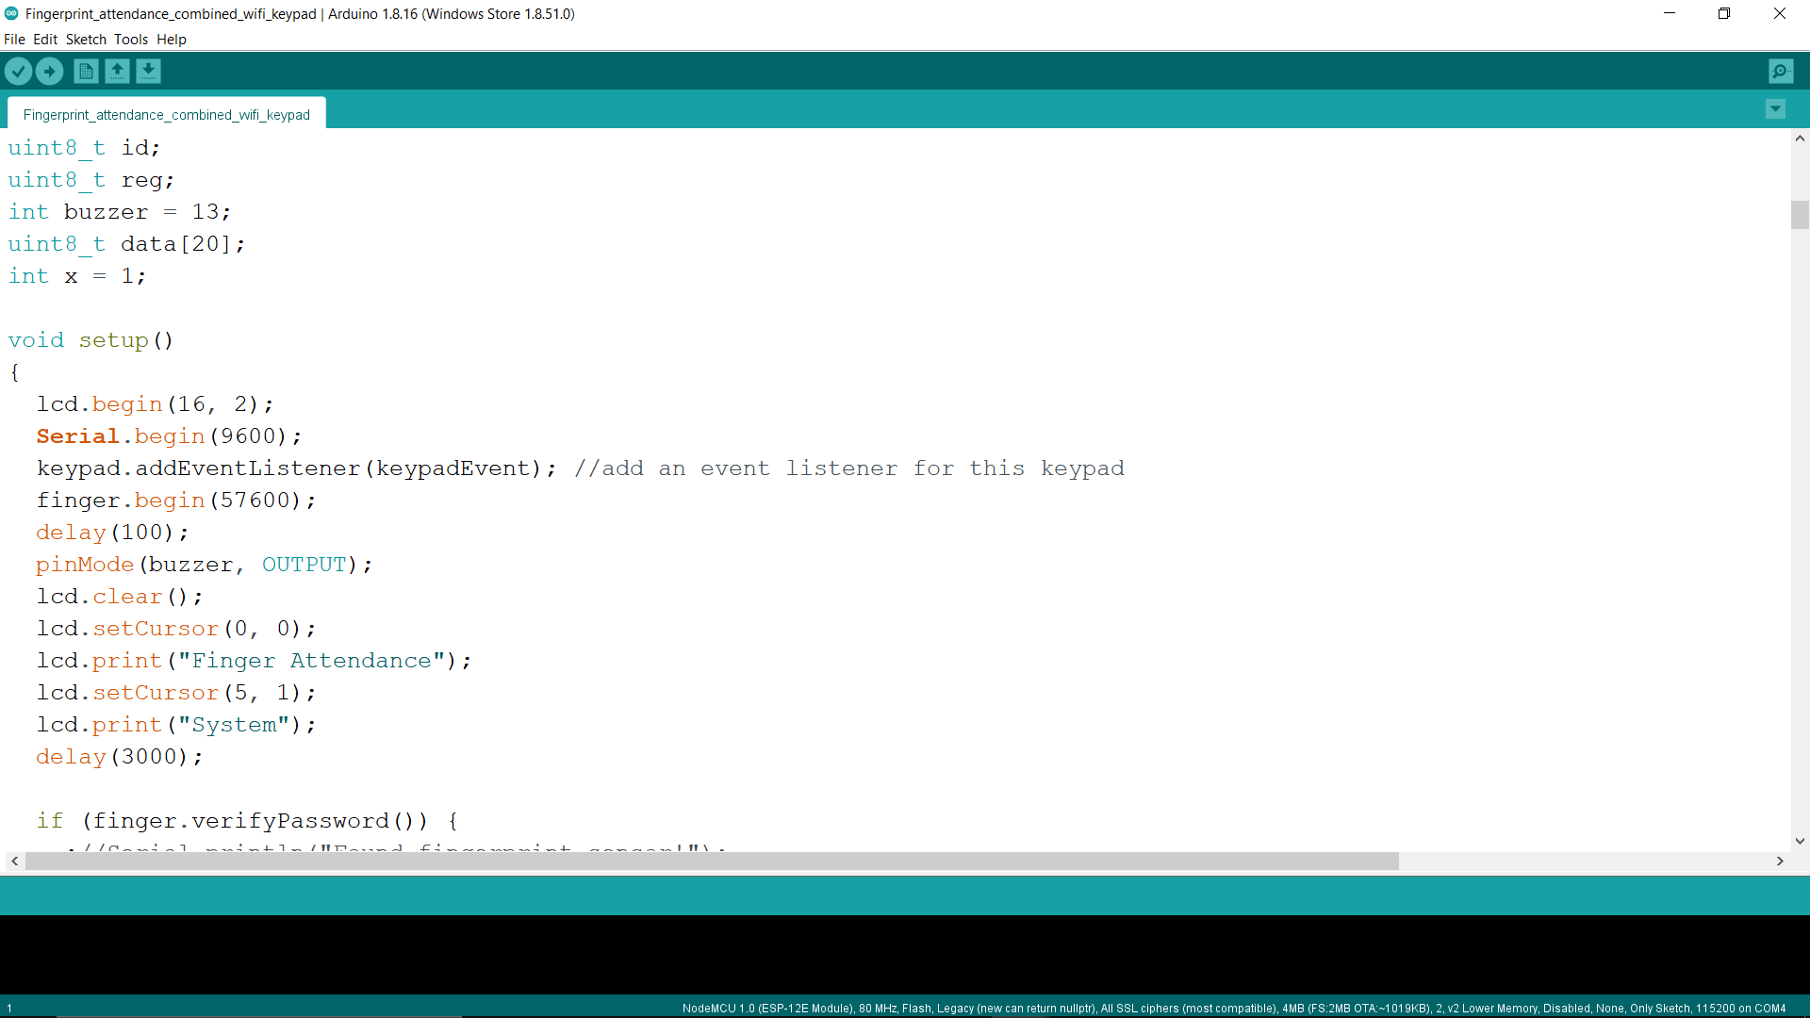

Figure 3. 9: A snippet of an Arduino code

The code needed to run the NodeMCU and the entire circuit is written on the Arduino IDE.

#### 3.2.2.2 MICROSOFT SQL SERVER

Microsoft SQL Server is developed and maintained by Microsoft. It is a Relational Database Management System (RDMS) whose primary objective is to store and retrieve data as requested by other applications. It is platform-dependent and is used to create databases, maintain databases, and generate reports.

To get a standard attendance management system, we need to collect and group the data from the device. To group data in Microsoft SQL Server, we have to create tables. Tables are used to store data and they show the attributes of data entities. Four tables were used for the execution of this project.

FACULTY TABLE:

This table contains the lecturers’ details, course name, number of lectures and total students present.

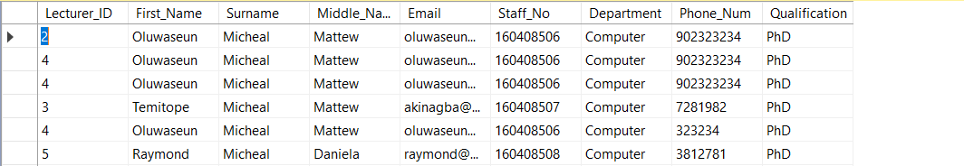

STUDENT TABLE:

The student table contains the students’ details, fingerprint Id and email addresses.

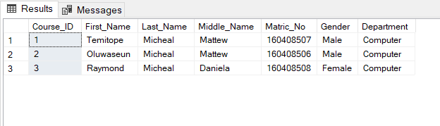

COURSE TABLE

This table contains all the registered courses available to the lecturers.

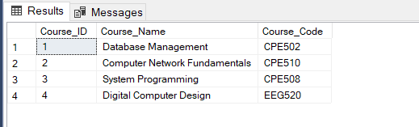

ATTENDANCE TABLE

This is the attendance sheet of the day; it contains the timestamp, the student’s name, course name and the attendance status which takes a Boolean value (1 for present and 0 for absent).

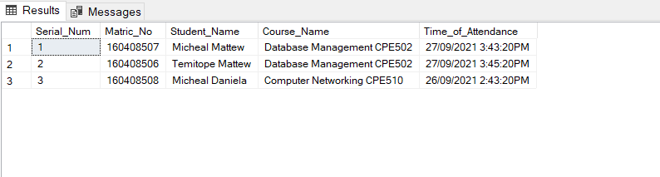

The data on the database will be passed to the web application with the help of SQL. SQL queries are used to retrieve and manipulate data from the database.

Both lecturers and students will be able to access the web application. The lecturer will be in charge of enrolling students, creating new attendance sheets, exporting attendance reports and managing students. The students are only privileged to view the attendance report.

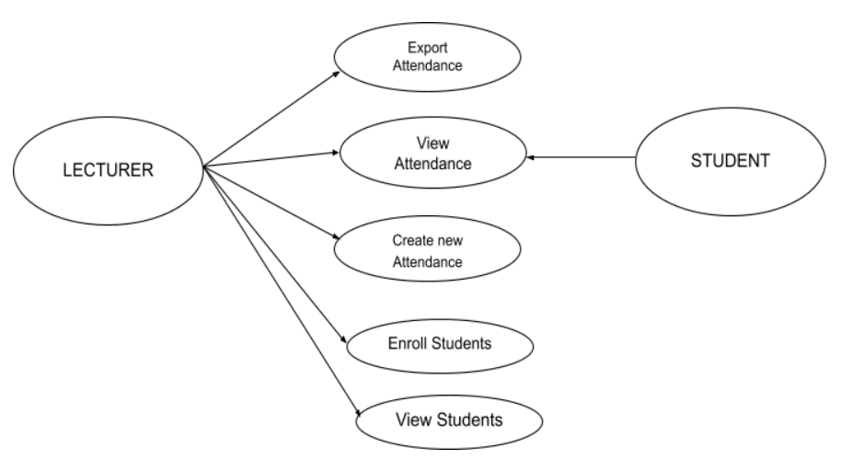

Use Case Diagram of the attendance management system

## 3.3 WORKFLOW OF THE SYSTEM

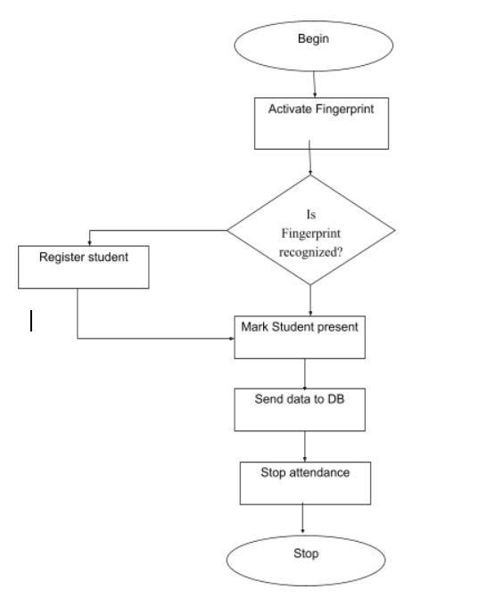

Figure 3. 10: Workflow of the proposed system

## 3.4 MODE OF OPERATION:

The following are the procedures involved in operating this system:

* Connect the device to the internet.
* Enroll students' fingerprints on the database. All students must have a fingerprint Id.
* Use the fingerprint module to scan the students’ fingerprints. New students will be prompted to enroll on the database while old students will be welcomed into the class. This process is to be repeated till the end of the class or as the lecturer pleases.
* Students’ fingerprint IDs will be sent to the database.
* A message will appear on the LCD display to signify the end of the attendance process.
* At the end of the class, the lecturer can view the attendance sheet on the website and he/she will be able to download it.

# 

CHAPTER 4

# DESIGN ANALYSIS

## 4.1 INTRODUCTION

This chapter explains the design procedure. It describes the flow of the steps taken to complete the project. The methodology is divided into two parts, one is building the IoT device and the other is developing the web platform for managing the attendance.

## 4.2 FLOWCHART OF PROJECT EXECUTION

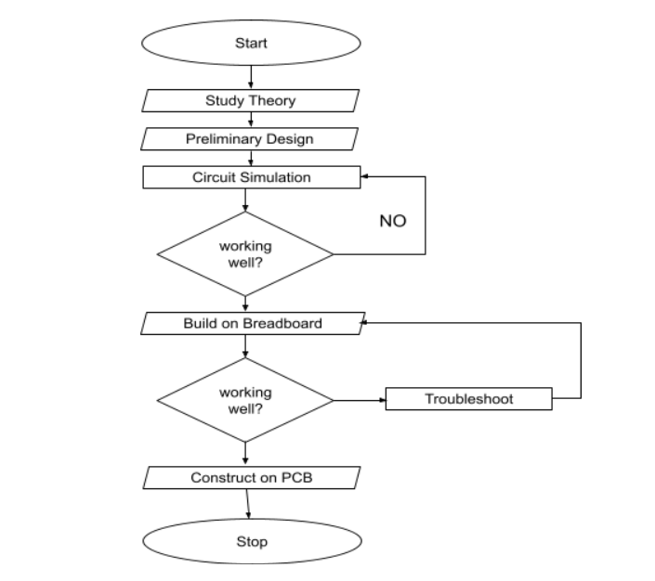

Figure 4.1: Flowchart of project execution.

The project design and implementation are divided into THREE sections:

i. Programming the microcontroller.

ii. Building the device.

iii. Developing the web platform.

## 4.3 PROGRAMMING THE MICROCONTROLLER:

The microcontroller used is the Atmega328p microcontroller. It is a high-performance microcontroller and it consumes less power. It is connected to the Arduino Uno board and then programmed. The device is programmed to connect to the internet via the wifi module, enrol new students' fingerprints ID, start the attendance and send the attendance report to the database. The microcontroller is responsible for enrolling students, it can enrol up to 1000 students’ fingerprints. The wifi module is programmed to collect data from the microcontroller and send data to the server database.

|  |
| --- |
| void Enroll() {  id = id + 1;  getFingerprintEnroll();  delay(2000); }  uint8_t getFingerprintEnroll() {   int p = -1;  lcd.setCursor(0, 0);  lcd.print("Place finger ");  lcd.setCursor(0, 1);  lcd.print("on scanner ");  while (p != FINGERPRINT_OK) {  p = finger.getImage();  switch (p) {  case FINGERPRINT_OK:  lcd.clear();  lcd.print("Image taken");  break;  case FINGERPRINT_NOFINGER:  //Serial.println(".");  break;  case FINGERPRINT_PACKETRECIEVEERR:  lcd.clear();  lcd.println("Communication error");  break;  case FINGERPRINT_IMAGEFAIL:  lcd.clear();  lcd.print("Imaging error");  break;  default:  lcd.clear();  lcd.print("Unknown error");  break;  }  } |

Figure 4.2: A C-Programming language function for enrolling students’ fingerprints

## 4.4 BUILDING THE DEVICE

The device was initially simulated using the Proteus software. The essence of this is to ensure that I am using the right specifications of the equipment. After simulation, the equipment was connected according to the circuit diagram shown in figure 3.9.

The device uses a Real-Time Clock (RTC) to send the current date and timestamp to the database. It has a keypad for accepting users’ inputs and for interacting with the user.

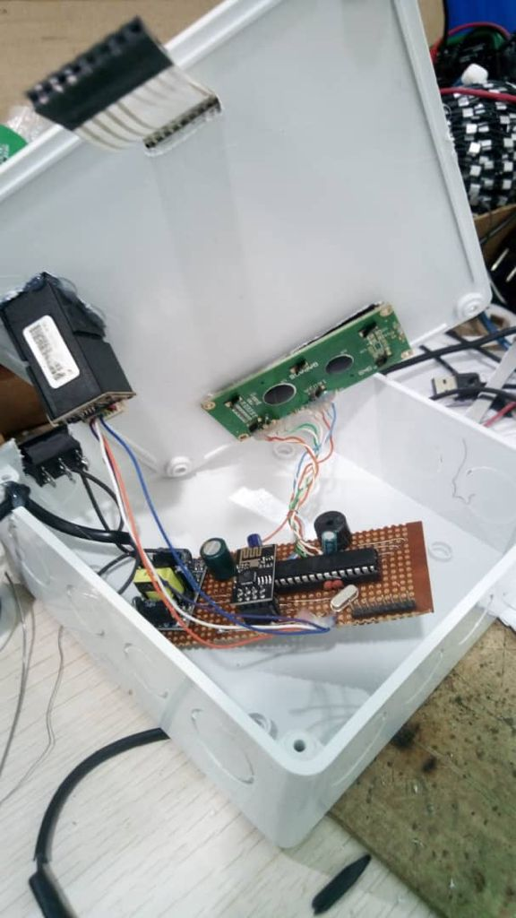

Figure 4.3: The PCB layout of the project

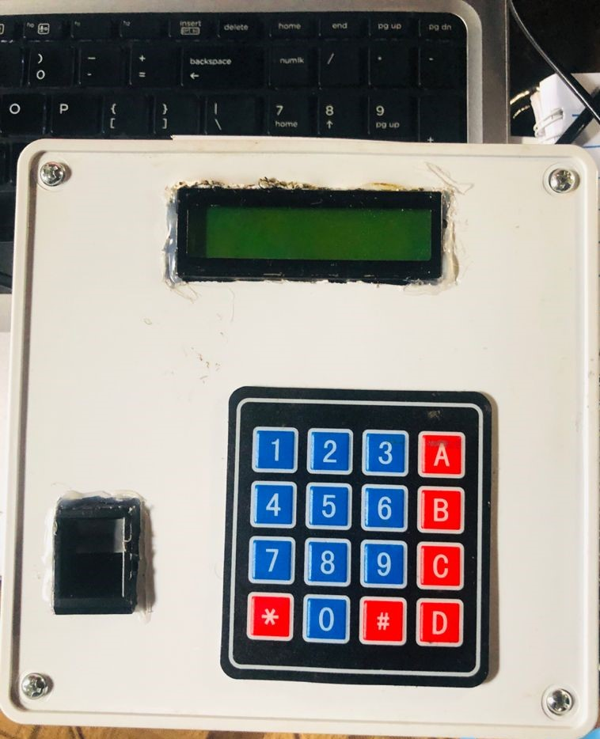

Figure 4.4: The complete Project

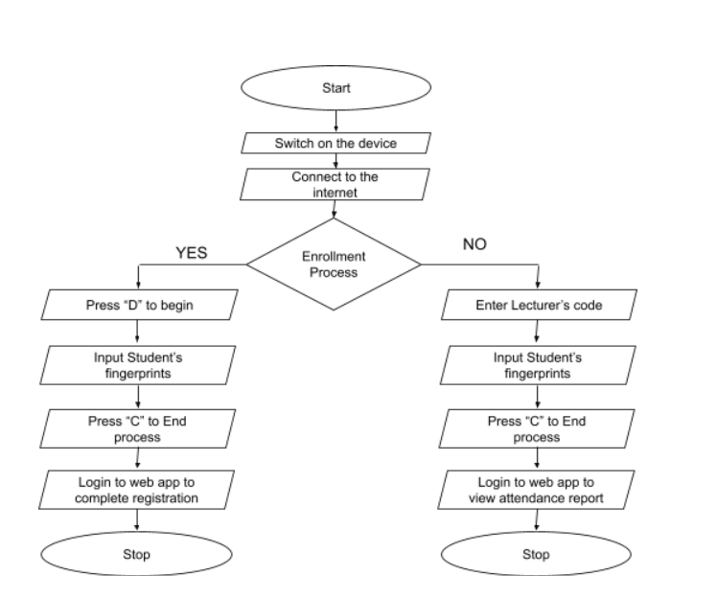

Figure 4.5: Workflow of the attendance procedure

### *4.4.1 DEVICE INSTRUCTIONS:*

1. Buttons 1,2,3,A,B are for lecturers passwords
2. The “#” button is used to delete or clear the screen.
3. The “D” button is used to commence the enrollment process.
4. The “C” button is used to end the attendance taking process. This should be pressed at the end of the class.
5. The “*” button serves as the Enter button.

### *4.4.2 ALGORITHM FOR ENROLLING NEW STUDENTS:*

1. Switch on the device.
2. Connect the device to the internet.
3. Press the “#” button to clear the screen.
4. Press the “D” button to begin the enrollment process.
5. Enter the student’s fingerprint twice.
6. A Fingerprint ID will be generated for each successful enrollment. This fingerprint ID is inserted in the students’ record while registering them on the web application.
7. Press the “C” button to signify the end of the enrollment process.
8. Login to the web application either as an Admin or a lecturer to complete the student's registration process.

### *4.4.3 ALGORITHM FOR TAKING ATTENDANCE:*

1. Switch on the device.
2. Connect the device to the internet.
3. Press the “#” button to clear the screen.
4. Input the lecturer’s password to begin the process. The essence of this password is to ensure that only authorized users can use the device.
5. Enter the students’ fingerprints
6. Press the “C” button to end the attendance process.
7. Login to the web application to view the attendance report. The attendance report can also be generated as a pdf file.

## 4.5 DEVELOPING THE WEB PLATFORM

The frontend of the web application is written in HTML, CSS, Bootstrap, Javascript. The backend is developed with the C# programming language using the .net Core MVC framework. The Agile SDLC model was used to develop this project. The web application is hosted on [smarterasp.net](https://www.smarterasp.net/) and can be found at <http://fpattendance-001-site1.ctempurl.com>. The repository of this project can be found in <https://github.com/Temmytope-seun/EAttendance>.

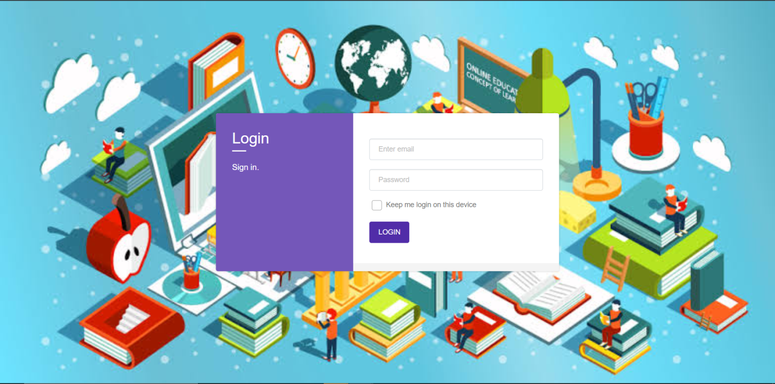

Figure 4.6: The Login Page

Figure 4.6 shows the login page of the web application. When a registered user enters their credentials, it will take them to their homepage depending on their roles. and if the login credentials are wrong, an error message will appear saying invalid login attempt. There are three homepages for this software, one for the Admin user, one for the lecturers and one for the students. Figure 4.7 shows the flow chart of the Login Page.

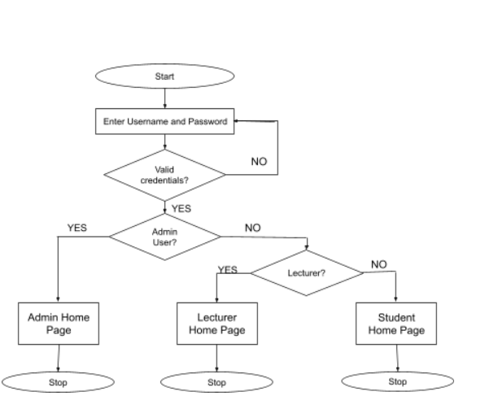

Figure 4.7: Flow Chart of the Login Page.

Figure 4.8 shows the user interface for the Admin User. The Admin has the privileges of creating new students, new lecturers, creating courses, assigning courses to lecturers, viewing attendance records and also deleting any record. These actions are performed on the database but displayed on the web page.

Figure 4.8 : The Admin Home Page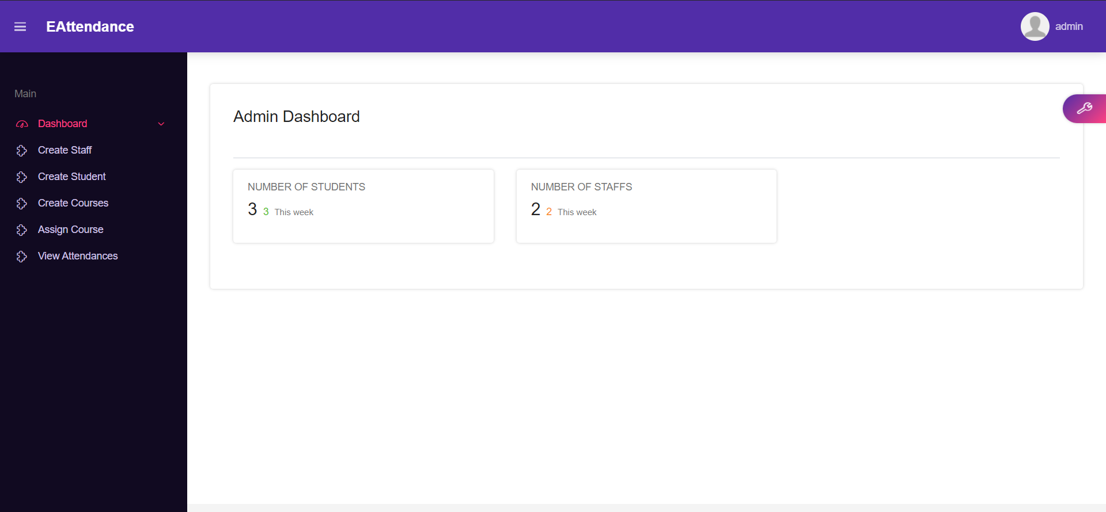

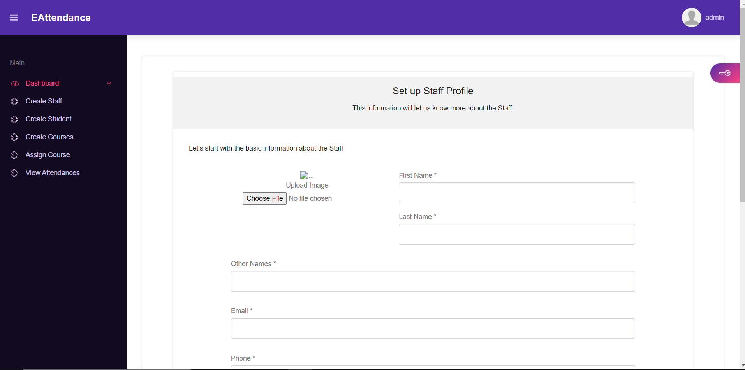

Figure 4.9: Admin creating new Lecturer

The Admin user is responsible for registering lecturers and students on the platform and assigning courses to the lecturers. The lecturers can also register students. Students are registered on the platform with the fingerprint ID generated from the IoT device. Students can login to the platform with their matriculation number and password.

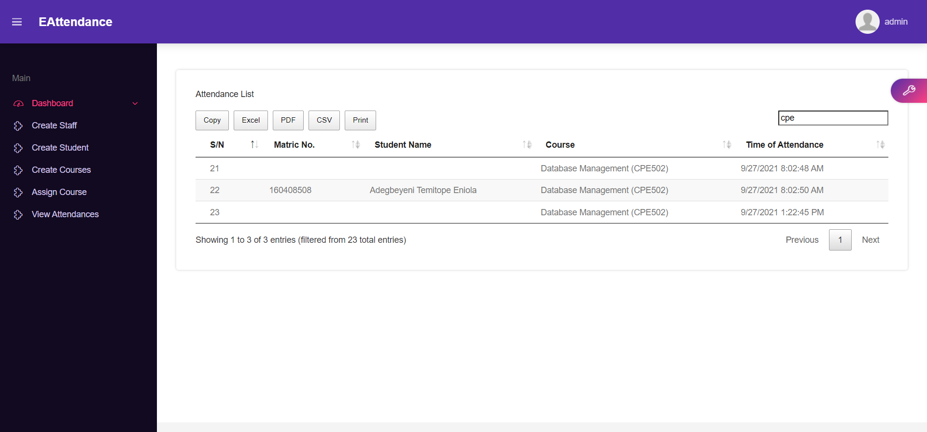

Figure 4.10: The attendance record.

The attendance record can be downloaded either as a pdf file or in an excel format. It can also be filtered by time of attendance or by course.

# 

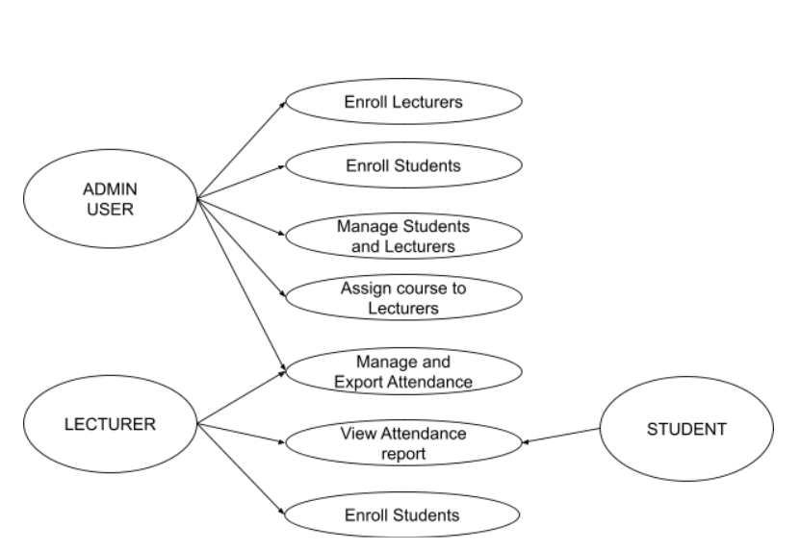

Figure 4.11: Use case diagram of the attendance management system

## 4.6 LIMITATIONS TO THE DEVICE

1. It can only be used for six (6) courses due to the low memory of the atmega328p microcontroller.
2. It can only register 1000 students' fingerprints.
3. It can’t be used without electricity.

CHAPTER 5

# CONCLUSION

This project has shown that the challenges which emerge when we use the traditional methods of taking attendance can be eliminated. This project aims to develop a secure, portable, time saving and accurate fingerprint-based attendance system. This system provides a simple and effective way to keep track of students’ attendance on a large scale. This device uses a fingerprint module to register and sign in students. The device is fully functional, user friendly and cost-effective. For these reasons, the device presents undeniably more benefits that can overshadow the present limitations.

## 5.1 SUGGESTION FOR FUTURE WORKS

Following the successful completion of this project, I would propose the following for further research on this project:

1. The adoption of a charging system to make the device operate with rechargeable batteries.
2. A mobile version of the web application can be developed to enable lecturers to manage the attendance system from their mobile devices.
3. Adding more RAM to the device so the system can accommodate more lecturers and users.
4. Functionality can be added to send mail to absent students. This mail would be informing them about the consequences of missing attendance.

CHAPTER 6

# REFERENCES

[1] T. Jain, U. Tomar, U. Arora, and S. Jain, “IOT based biometric attendance system,” *Int. J. Electr. Eng. Technol.*, vol. 11, no. 2, pp. 156–161, 2020.

[2] A. K. A. J, P. Suchetha, Y. C. C. S, and K. R. Sumana, “Smart Student Monitoring System using RFID,” *Int. Res. J. Eng. Technol.*, vol. 4, no. 6, pp. 631–633, 2017, [Online]. Available: https://irjet.net/archives/V4/i6/IRJET-V4I6115.pdf.

[3] M. Kumar Thakur, R. Shankar Kumar, M. Kumar, and R. Kumar, “Wireless Fingerprint Based Security System Using Zigbee Technology,” *Int. J. Inven. Eng. Sci.*, no. 1, p. 14, 2013.

[4] J. J. (Jon. H. Park, Y. Pan, C. Kim, and Y. Yang, “Future Information Technology - II,” *Lect. Notes Electr. Eng.*, vol. 329, pp. 213–231, 2015, doi: 10.1007/978-94-017-9558-6.

[5] A. Kassem, M. Hamad, Z. Chalhoub, and S. El Dahdaah, “An RFID attendance and monitoring system for university applications,” *2010 IEEE Int. Conf. Electron. Circuits, Syst. ICECS 2010 - Proc.*, pp. 851–854, 2010, doi: 10.1109/ICECS.2010.5724646.

[6] S. Kadry and K. Smaili, “A design and implementation of a wireless iris recognition attendance management system,” *Inf. Technol. Control*, vol. 36, no. 3, pp. 323–329, 2007.

[7] G. Sittampalam and N. Ratnarajah, “SAMS: An IoT Solution for Attendance Management in Universities,” *IEEE Reg. 10 Annu. Int. Conf. Proceedings/TENCON*, vol. 2019-October, pp. 251–256, 2019, doi: 10.1109/TENCON.2019.8929616.

[8] L. Kamelia, E. A. D. Hamidi, W. Darmalaksana, and A. Nugraha, “Real-Time Online Attendance System Based On Fingerprint and GPS in the Smartphone,” *Proceeding 2018 4th Int. Conf. Wirel. Telemat. ICWT 2018*, pp. 2018–2021, 2018, doi: 10.1109/ICWT.2018.8527837.

[9] S. Ghosh, S. K. Mohammed, N. Mogal, P. K. Nayak, and B. Champaty, “Smart Attendance System,” *2018 Int. Conf. Smart City Emerg. Technol. ICSCET 2018*, pp. 4–8, 2018, doi: 10.1109/ICSCET.2018.8537298.

[10] S. Bhattacharya, G. S. Nainala, P. Das, and A. Routray, “Smart attendance monitoring system (SAMS): A face recognition based attendance system for classroom environment,” *Proc. - IEEE 18th Int. Conf. Adv. Learn. Technol. ICALT 2018*, pp. 358–360, 2018, doi: 10.1109/ICALT.2018.00090.

[11] Stephen Mayhew (2012, July 18). History of Biometrics. *Biometric Update.* Retrieved from https://www.biometricupdate.com/201802/history-of-biometrics-2.

[12] Ricky Ribeiro (2016, May 17). Biometrics Could Improve Speed and Accuracy in Fighting Crime [#Infographic]. *StateTech Magazine.* Retrieved from https://statetechmagazine.com/article/2016/05/biometrics-could-improve-speed-and-accuracy-fighting-crime-infographic.

[13] Rerinans (2019, August 28). How does Palm vien technology works?. *Field Constructs.* Retrieved from http://fieldconstructs.org/how-does-palm-vein-technology-work/.

[14] Stephen Mayhew (2012, June 18). Explainer: Hand Geometry Recognition. *Biometric Update.* Retrieved from https://www.biometricupdate.com/201206/explainer-hand-geometry-recognition.

[15] Ravis Das (2015, October 1). Hand Geometry Recognition. *Kessing Platform.* Retrieved from https://platform.keesingtechnologies.com/hand-geometry-recognition/.

[16] Tom Harris (2018, April 24). How Biometric Works. *HowStuffWorks.* Retrieved from https://computer.howstuffworks.com/fingerprint-scanner.htm.

[17] “What is Iris Recognition and how does it work?” (2019, October 8). *NEC New Zealand.* Retrieved from https://www.nec.co.nz/market-leadership/publications-media/what-is-iris-recognition-and-how-does-it-work/.

[18] M. Sarma, A. Gogoi, R. Saikia, and D. J. Bora, “Fingerprint Based Door Access System using Arduino,” August, 2020.

[19] Finger Print Sensor (R305)-TTL UART (2020, September 18). *rhydolabz.* Retrieved from https://www.rhydolabz.com/miscellaneous-other-widgets-c-205_124/finger-print-sensor-r305-ttl-uart-p-1085.html.

[20] “Nodemcu Esp8266 Pinout Features and Datasheet” (2020, April 20). *Components101.* Retrieved from https://components101.com/development-boards/nodemcu-esp8266-pinout-features-and-datasheet.

[21] 16X2 LCD Display with I2C (2020, April 20). *Ebotics Educational Robotics Kits* Retrieved from https://ebotics.com/product/16x2-lcd-display-with-l2c/.

[22] “Software Arduino” *Arduino* Retrieved from: <https://www.arduino.cc/en/software>.

[23] “Interface DS3231 Precision RTC Module with Arduino” (2020, July 21). *Last Minute Engineers.* Retrieved from <https://lastminuteengineers.com/ds3231-rtc-arduino-tutorial/>.

[24] Henry (2021, January 30). Introduction to Atmega328p Mircocontroller. *The Engineering Knowledge.* Retrieved from https://www.theengineeringknowledge.com/introduction-to-atmega328p-microcontroller/.